WWW.DDEBARRA.IE
From Dal gCais 1986
______________________________________________________________________________
The Lore of the Sea
in County Clare
From the collections of the Irish Folklore Commission
by Bairbre Ó Floinn
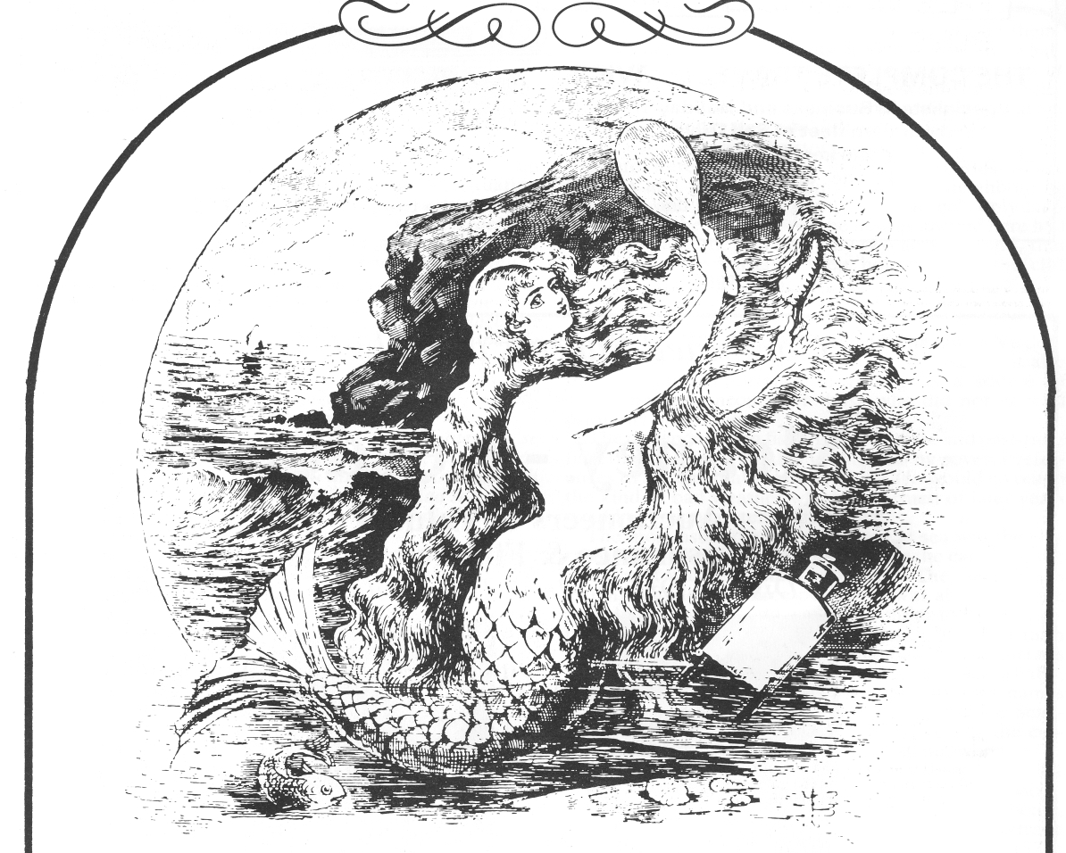
The county of Clare is surrounded by water on three of its four sides: north Clare forms part of the coast line of Galway Bay, west Clare is confronted abruptly by the Atlantic, while the Shannon Estuary forms the southern borders of the county. The people of Clare have long had the reputation of valuing and maintaining their traditions, so it is hardly surprising that the combination of long coast-line and rich tradition should result in an enormous wealth of lore about the sea in County Clare.
Fifty years ago, the Irish Folklore Commission set itself the task of collecting the traditions and stories of
107
people throughout the country. Clare was not forgotten, and four full-time collectors were appointed, at different periods, to work in that county. Tadhg O Murchú collected in the south-west of Clare, where Seán MacCraith also worked for a time. Ciarán Báiréad and Seán Ó Flannagáin gathered material in the north and north-east of the county respectively. Mention should also be made of the important contribution of Seán MacMathúna who collected about 11,000 pages of material during his years as a part-time collector in west Clare.
And, of course, there were others. These included T.J. Westropp, the Co. Limerick-born antiquarian who collected and published a substantial amount of material from the coast of Clare and from other parts of the west. They also included the man who was largely responsible for the founding of the Irish Folklore Commission, and who acted as its director for the duration of its existence, Seamus Ó Duilearga. He interested himself principally in the Irish of Co. Clare, and did quite intensive collecting work from Irish speakers in the county, many of whom lived along the coast.
In more recent times, Clare has again been given the full-time collector it deserves, in the person of Tom Munnelly, working from his base in Miltown Malbay. Tom's collections include, inevitably, much information about the sea and matters relating to it. This fertile source of sea-lore lies outside the scope of this article, however, as Tom did not take up work as a full-time collector until after the replacement of the Commission by the Department of Irish Folklore in University College Dublin, in 1971.

"Only half-fishing in the Seasons":
Decline of the industry in Clare

The sea was, and is, important to the people living along the coast of Clare in a very real and practical way, in that it had an important part to play in the traditional economy of coastal communities. Indeed, this was probably more the case in former times than it is today. Sean MacMathúna gives us a good description of the situation as it was about 80 years ago in the Doolin area:
‘Insan an tsean-tsaol (sic), ba chúnamh maireachtála don fheirmeoir beag an fharraige agus an trá, chomh maith leis an dtalamh. Bhí go leor de na feirmeoirí ina niascairí no ina mangairí éisc i dteannta bheith ina bhfeirmeoirí. Gan dul thar an logán seo, deir seandaoine liom go mbíodh dhá churach dhéag ag gabháil amach on dTrá Leathan anseo thíos, áit ná fuil curach ná bád le fada an lá. Agus bhíodh ceithre churach le fheichead thoir i mBealach a' Laghan, agus gan ann anois ach cúig no sé chinnibh. Agus mara dtagann athrú saoil, ní fada eile a bheidh an oiread sin féin ann...
Maidir leis na hiascairí do bhí timpeall na háite seo, 'sé an corrdhuine acu do bhíodh gan a bheag no a mhór talún insan seanaimsir féin. Fiú an dream do dhéanadh ceard mhaireachtála den iascaireacht, mar iad seo thoir i Sráid na nIascairí, bhíodh stang mhaith de gharraí tuair sa ngainimh i seilbh gach duine acu...
Ach bhí iascairí gairid don áit seo, thíos i Lios Ceannúir, ná raibh aon seift acu chun iad féin agus a mbíodh ag brath orthu do chothú, ach a gcuid maidí rámha, ach pé rud do bhainidíst as ceilp no múrach....Ach bhíodh paiste beag talún ag formhór na hiascairí (sic) do bhí ar na mbaile seo, agus bhí rud eicínt acu he baint as an dtalamh an lá ná friotháileadh an fharraige dhóibh'. (IFC 670 : 305-9) (1).
(In the old days, the sea and shore helped the small farmers to live, as well as the land. Many of the farmers were fishermen or fish-merchants as well as being farmers. Without going outside this little place, old people say that there used to be 12 currachs going out from the Trá Leathan here below, where there hasn't been a currach or a boat for many's the long day. And there used to be 24 currachs over in Ballaghaline, where there's only five or six now. And, as things change, it won't be long until there's not even that amount there...
In the case of the fishermen around this place, it was a rare one was without some bit of land long ago. Even the crowd who lived on fishing, like the ones over in Fisherstreet, they'd have a good bit of fertile garden in the sand...
But there were fishermen near this place, down in
Liscannor, who had no means of supporting themselves and their dependants but their oars, and whatever they would make from kelp and seaweed... But most of the fishermen in this village would have a little patch of land, and they could make something from the land the day they couldn't go out fishing).
In the Corbally area, the story was the same:
There were nine canoes fishing out of this village alone and five more from Farrihy (a neighbouring place), and now there's only one and he's only half-fishing in the seasons. All the houses around here had a canoe and they all had only two acres of land, that ran from the backs of their houses down the cliff edge'. (IFC 1392: 323). i.

Accounts such as these clearly indicate not only a definite decline in fishing activity along the coast, but also the one-time importance of fishing as a source of supplementary income for those who did not depend primarily on fishing.
The dependence on fishing, by full-time and part-time fishermen alike, is further illustrated by several references to the fact that fishermen long ago would go out in the kind of bad weather which fishermen of later years would not even contemplate facing.
The most usual type of craft used at sea was the currach, as it was called in north Clare, or the canoe, as the same craft was called in south Clare. The currach was usually manned by three people. It was about 18' long and almost 4' wide, and was very similar to its counterpart from the Aran Islands (2). Seán MacCraith recorded a good description of the making of a currach from an old currach-maker, John Marrinan of Corbally, in 1955. (IFC 1392 : 321-5). Among the other names associated with currach-making, there were the Scanlans of Kilrush, who used to lay the laths for the currachs, and the Brennans of Scattery Island, who used to perform the job of covering them with canvas (IFC 1391 : 10), There was also Jeremiah McMahon of Kilrush. Jeremiah was a sail-maker, primarily, for the turf-boats, and he used to claim that he was the only man of his trade in the county before his death in about 1920 (IFC 1371 : 212).
The currachs would usually be owned in partnership, according to Seán MacMathúna:
`Mar a bhíodh, agus mar a bhíonn, an sceal i measc iascairí i ngach uile áit, is amhlaidh do bhíodh gach uile churach i bpáirt idir beirt no tiúr. Cheannaídíst an curach i bpáirt, roinndíst an t-iasc i bpáirt, agus mar an gcéanna leis an t-airgead (sic) a d'fhaightí air'. (IFC 670: 309).
109
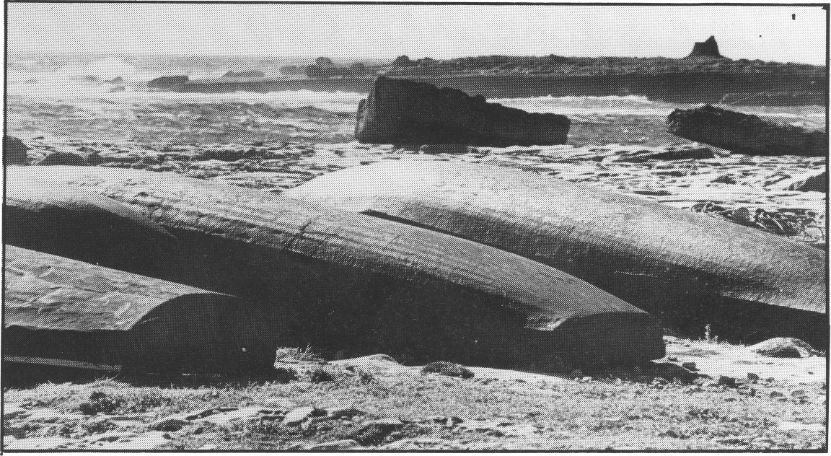
• Currachs at Doolin. Photo: Clare County Library.
(How things were - and how they are among fishermen everywhere - was that every currach would be shared by two or three. They used buy the currach together, divide the fish up between them, and the same with the money they would make).
The fishing was comparatively rich and varied. In the spring and summer, spillers, or long-lines, were used. The spiller might have up to three hundred hooks on it, baited with lug-worm, and was used to catch cod, ling, sole, plaice, haddock, gurnet, hake etc. Drift-nets were used to catch mackerel in the late summer months, and for herring during the winter. Trammels were also known, and were used in spring and summer to catch pollock, bream, rock-fish and mackerel. Lobster were caught along those stretches of coast which were suitably rocky. The lobster season extended from about June to September, and the lobster-pots were usually made locally from rods. Along some parts of the coast, however, it seems that lobster-fishing is a fairly recent introduction. According to John Joe Murrihy of Quilty, for example, lobster-fishing in his area started only about 20 or 25 years ago. John Joe has recorded a detailed description of the fishing industry as it was in Quilty about 60 years ago, which follows closely the overall pat-tern outlined above. (3). He also points out that, at that time, there were about 21 three-man currachs fishing off Seafield, where today there are only four or five two-man boats fishing lobster for a few months of the year. This decline in activity is still to be seen today in the form of the deserted fish-curing station at Seafield.

"Twas unlucky to swear in a canoe":
Fishing and Folk beliefs.

In Co. Clare, as in every other part of the country, the whole business of fishing attracted to itself a large number of beliefs and customs. Fishing, as an occupation, is highly prone to luck-beliefs, and understandably so. The level of unpredictability in fishing is extremely high, and the risk factor operates on two levels: the per-
sonal and the economic. Not only is the fisherman often in very real physical danger, but his livelihood is also threatened by the unpredictability of the fish-catch. It would be a foolish man indeed who would make changes in such a situation. The following collection of beliefs is from the Kilbaha area:
`The seventeen canoes who used to fish from Kilbaha in my time always carried three things in a canoe. A horse-shoe was nailed down to the centre board of the canoe, a little bottle of holy water from St. Cuán's well was tied to one of the laths that ran from bow to stern, and in the stern of the boat they used to have a holy picture of some sort. A little card of the Sacred Heart was common, but some canoes had cards of little prayers or short verses of Gospels on them. When the canoes put out at the last half-hour of sunset, the bow-man always looked to the Ross rise and blessed him-self, and other men did likewise. We never fished on St. Brigid's Eve, on St. Patrick's Eve or Day, neither did we go out on May Day or May Eve, nor on St. Martin's Day. We never went out from the 29th of October until the 3rd of November as these few days covered All Saints and All Holy Souls Days. Any month that had no `R' in it was supposed to be unlucky for killing mackerel, and the first herring caught in the first Harvest Haul was thrown out of the canoe immediately the canoe pulled in its nets to the side. Nets should be cast just before the point when the sun was setting - this was a wide custom always in this area'. (IFC 1392: 285).
From Corbally:
`You never said a vulgar curse or bad language in the canoe, and there were times when a man said many a quare one under his lips, but 'twas very unlucky to curse or swear in a canoe. This applied whether you were fishing or not. When the canoe was pulled out from the slip or wherever she was tied, great care was taken to see that the painter (a rope) did not drip into the water. `Twas bad for a man to change his seat in a canoe, and long ago very few fishermen took out non-fishermen or strangers (visitors) as they were said to be unlucky objects sitting in the stern. In a three-man
111
canoe, a fourth person, no matter who he was, sat in the stern cradle or seat...
A new moon, if you saw it through your window and you going out fishing, was the worst thing to see, and you'd be better off to stop indoors that night. Of course, no man would like to pass a red-haired woman, a weasel or a magpie, and if you met any of these three, you would bless yourself, and shift what-ever you carried in your hand to the other hand. A man might have a pair of oars, a bit of rope, maybe the nets under his arm, and if you met any of the three I mentioned, you should change them to the other arm or hand after crossing yourself (blessing yourself)'.
(IFC 1392:312) .

In some parts of the country, there existed a rich tradition of euphemism among fishermen. It was believed to be unlucky to mention certain things by their correct name, and alternative names were used instead. Such things included, for example, foxes, hares and priests. This seems to have been the case particularly among full-time, professional fishermen. This tradition has not been found among Clare fishermen, to any great extent, which is not surprising in view of the fact that fishing in Clare was never developed as a proper industry. For this reason, there were comparatively few full-time fisher-men in the county, and the farmer-fisherman situation, as described earlier, prevailed instead.
Before leaving the subject of fishing altogether, mention should be made of another type of fishing which was practised along the Clare coast - that of fishing from a cliff-top with a rod and line. The following is a brief description, recorded by Ciarán Bairéad from John McDonagh of Moher:
`We fished for rockfish and bream and pollock all around the cliffs. We fished with a hazel wattle... The baits we had were bairneachs and pennywinkles (sic) and crabs. We fished from the month of May on to October and November, if it was fine. The line would be half a fathom. We never sold the fish but stored it up for our own use for the winter. You had to climb down the Cliffs of Moher to within fifteen fathoms of the water.
There was places where you could sit down. Ceann Poll was one of them, for the bream. Ballán Dónall was above Ceann Poll - they fished from that for rock-fish.... There was another place they call the Cathaoir, and they fished from that. There was another place they call Leac na Sagart, a couple of hundred feet down. They goes down there - get on a rope, drive a bar into the ground half-way down and tie the rope onto it, and you come on the strength of your hands. You'd have the rope tied around your middle. You'd get the bream there. She's still there,but nobody goes down now.
A calm, dark, foggy day was the best for fishing
there, with the spring tide'. (IFC 1863 : 87-8).
The Commission also recorded several accounts, too numerous to include here, of the craft of cliff-fowling in Co. Clare. Suffice to say that cliff-fowling used to be carried out on the Cliffs of Moher - among other places -and that a rope would often be used in a similar way to that described above in connection with rock-fishing, in order to get at the sea-birds and their eggs.

Shore-gatherers and Kelp-makers

An intrinsic part of life for coastal communities in Clare, as elsewhere, was shore-gathering and the making of kelp. Henry Blake, from Kilbaha, had this to say:
`During the off-fishing times, the men used to go at the
kelp... they gathered the seaweed and dried it, and then they buried it in large pits (which) they dug in the ground. They then set fire to it and made kelp of it'. ((IFC 1392 : 292).
According to John Joe Murrihy of Quilty, the men used to make kelp in June, in the lull between the end of the long-line fishing and the start of the mackerel fishing. About 60 years ago, it reached an average price of £15 to £20 a ton (4). Kelp was used to produce iodine, among other things.
Seaweed was also harvested and used as fertiliser by the local people. The Commission recorded many descriptions from Co. Clare of the hardship which this work involved. People often had to go out on stormy winter's night in order to gather the seaweed as the sea threw it up. It was work in which women were very much involved, and it was hard work. There are many accounts of women carrying large loads of seaweed in
baskets on their backs, and of their getting soaked to the skin by having to go into the sea in order to retrieve the seaweed in the first place.
One informant points out, however, that the work sometimes had its lighter side, in that there would often be a lot of young people involved in the work. When such was the case, the whole business could even be quite enjoyable, and almost assumed the atmosphere of a social get-together. (IFC 1044 : 47). Pádraig Shannon, of Doolin, describes the lóipíní which those engaged in shore-gathering often used to wear, and which consisted of the `butts' of closely-woven old socks (IFC 1797 : 396). It is easy to see that such footwear should give a good grip on wet rock, in exactly the same was as do the pampooties of the Aran Islands.
A constant source of resentment to shore-gatherers in some areas was the fact that, in law, a half of what was harvested belonged to the owner of the shore. The owner was usually a local farmer who would not have to
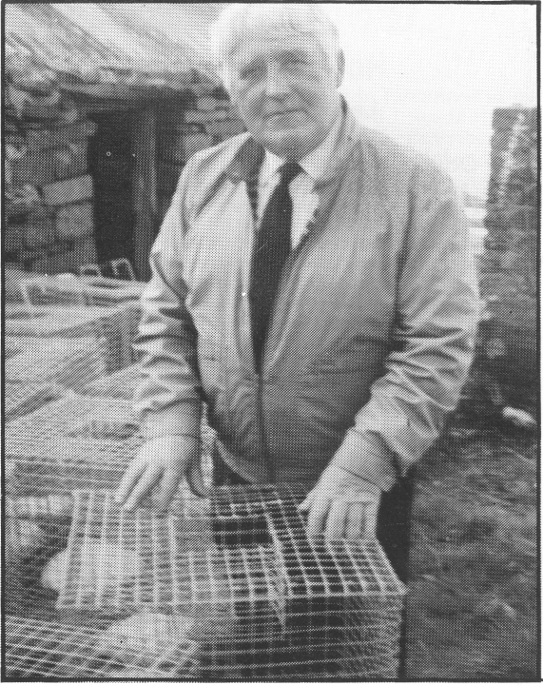
•John Joe Murrihy of Quilty. Photo Muiris Ó Rócháin.
113
actually engage in the hard work of harvesting the sea-weed, but who could still reap the benefit (IFC 1044 : 50-2).
There were of course, different kinds of seaweed, and these were often used for different purposes. Some of the more common varieties harvested included miaránach, feamainn chlogach, ruánach, rufaí, May weed, sea-rod and coirleach. Learach, or ribbon-weed, was sometimes eaten, as John McDonagh of Moher describes:
`They put it on the wall and bleached it white. 'Twas just as good as carrageen. They ate it - chop it up and put it down in the saucepan of water. You could put a drop of whiskey in it, or a drop of cream or milk'. (IFC 1863 : 86).
Sea-grass and cruitín were also eaten. They were often put down with bacon and boiled, instead of cabbage. (IFC 1863 : 95). Sleabhcán, another type of seaweed, was used as a substitute for milk, if milk was scarce in the winter or spring. It was washed very clean of all sand, and boiled in water for 24 hours. It was then chopped up in the boiling water, and the resulting mixture gave a thick liquid which was drunk instead of milk. It was said to be good and healthy for you (IFC 1042: 111).
Of course, widespread use was also made of many of the shell-fish which were picked on the strand. Cockles, limpets, winkles, etc. formed a part of the diet of those living by the sea, and shell-fish were also often used as bait by fishermen, as we have seen. One report from Kilbaha describes how a local man used to make use of mussels, not as food, but by spreading them on his land as fertiliser! (IFC 1393 : 104).
"That little harbour, twas like a wood": Trade and contact by sea.

Practical use was made not only of the fruits of the sea, but also of the sea itself, in that it was used as a means of communication and trade, to a far greater extent formerly than in the present day. In a period of poorly developed land-transport and road-systems, the sea was a means of unity and contact for coastal communities. Today, it is seen rather as a dividing force. In penal times, for example, people used to travel across the Shannon Estuary from Kerry to south Clare, in order to hear Mass. They would know when to come, as a fire would be lit on Reha Hill, near Kilbaha, and the Mass would be said on a big, flat rock known as Leac an Aifrinn (IFC 1392 : 268).
Seán MacCraith collected a great deal of information on the former busy trade up the Shannon, into Kilrush docks and Cappa pier. He has written about the Shan-non steam-boats which used to carry stout, butter and coal between Kilrush and Limerick, and about the many local turf-boats which used to carry turf (and a great many other things) - from Kilbaha and elsewhere to Limerick city. (IFC 1391 : 86-95 etc.).
With such a large volume of traffic, there was, predict-
ably, a correspondingly large amount of lore attached to
the Shannon pilots and their work in guiding ships safely
up the river. Seán MacCraith describes the situation: `At this time (c.1873) the traffic on the River Shannon was very heavy, and in addition to about twenty official pilots who lived in and around Kilbaha, there were also about twelve men who were known as `hobblers'. These were so called because they would not be granted licences to work as pilots. Many of the `hobblers' were, in fact, better pilots, but lack of education or `reading and writing', as they said in those days, prevented them from getting official status. The `hobblers' made good money - as did the pilots - but
the `hobblers' only got ships when circumstances pre-vented the official pilots from the course of their duty. When a boat or ship was expected, the `hobbler', along with a few mates, would pull out to the approaching ship, and from the slender body of his canvas currach or canoe, he would bargain with the master of the ship for a sum to steer the ship to her port of destination.
Very often, it was the `hobblers' only who would
venture out in tough weather, and they seemed to
tempt the stormy seas when the pilots considered it
dangerous to set out to board a ship'. (IFC 1392 : 251).
A song entitled The Five Pilots of Kilbaha is still to be heard in Co. Clare today. It tells of the tragic loss of the five men, and is believed to have been written by an Amy Griffin. Seán MacCraith describes the incident as. follows:
`On the 8th of May, 1873, a sailing-ship was sighted off Loop Head point. She was flying a pilot flag, and five pilots from Kilbaha decided to launch a canoe to put on board a man who was to take her up-river to Limerick...
All five were Kilbaha men, two in fact being related: Michael Brennan and his nephew, Tom Brennan,....John McNamara, Pat Carmody and Séamus Bán Crotty. As the five pushed the canoe out into the water, one of them said it was very rough, and a gale was rising to the north-west. An elderly man who was standing on the beach said to him `Five ould women would board her!', and apparently this remark caused the five to set out without thinking of the danger.
Rougher the tide was getting and the wind was howl-
ing in terrible long gusts. A crowd of people - kinsmen
of the five pilots - had gathered... to watch the canoe buffet her way amid the twenty-foot high breakers.The five never reached their destination, as, singly and in pairs, the gallant five laid down their lives trying to reach a ship in distress'. (IFC1392 : 251-2) (5).
Kilbaha and south Clare was by no means the only part of the county with a flourishing sea-trade. For example, Connie Hayes, who was born in about 1875, gives accounts of the thriving trade in Liscannor in his youth, with coal being shipped in, and Liscannor flag-stones being exported. He graphically describes the crowded harbour, in a day when all ships had sails and masts: `I saw that little harbour beyond - `twas like a wood!' (6).
The busy coming and going between north Clare, the Aran Islands and Connemara, provides further evidence of the way in which water was regarded as a means of communication, rather than separation. Aran people used to come in boat-loads to the annual pattern at St. Brigid's well, outside Liscannor, and there was constant traffic between the people of Inisheer and the Doolin area. Indeed marriages often took place between the two communities.
A little further north, along the north coast of Co. Clare, the trade and contact seems to have been mostly across the bay with Connemara. People from Connemara would come to Clare to sell turf and poitín, and they would, in turn, buy potatoes from the Clare people. Forty years ago, people from the New Quay area would regularly go to the Galway Races in the Connemara turf-boats - it was probably quicker to go this way than by road (IFC 1863 : 70).
The poitín trade to the Doolin area seems to have been partly through the Aran Islands. One reference also says that people around Doolin used often buy but-ter in Connemara, because it was cheap, and put it through their own butter, as it was believed to improve the quality (IFC 1043 : 293).
115
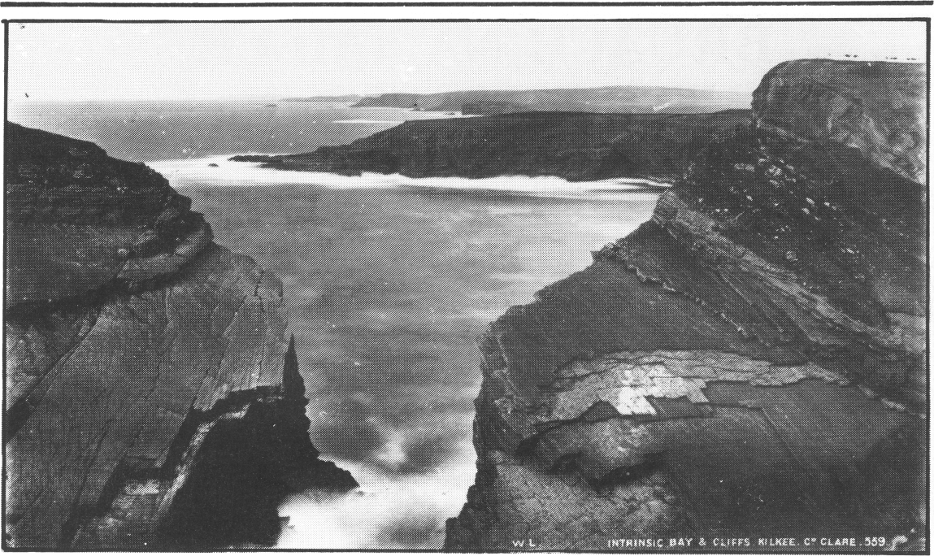
• Intrinsic Bay and Cliffs, Kilkee. Photo: Lawrence Collection, Clare County Library.
"Some ship like the Flying Dutchman": Shipwrecks, Sea Ghosts and Raic

Inevitably, accidents happened, and Clare sea-lore is full of stories about tragic wrecks and drownings. Happily, there are also stories about men who fought the sea and won. One such dramatic story tells of two brothers who were coming to Doolin from Connemara in a currach, with butter and poitín. As they got within sight of home, a gale suddenly blew up. Local people gathered on the beach to watch the struggle, unable to do any-thing to help the unfortunate men. Eventually, the two men made it safely to land, but were so exhausted that they had to be lifted out of the boat (IFC 1043 : 293-6).
Another story tells of three fishermen from near Doolin who are out fishing one day, when they get caught in a storm. They are eventually blown all the way up to Murrough in north Clare. Miraculously, they survive and are taken in and looked after by local people. One of the men is particularly determined to get home to his wife and family, however, and he sets off walking, leaving the other two fishermen behind. When he eventually arrives home, he gets to his house to find his own wake in progress! (IFC 1044 : 84-7).
Not so lucky were the three Aran men who left Ballaghaline pier in an old currach, carrying a goat and a donkey as well as themselves. They were heading for home, but nothing more was heard of them until the news came that their bodies had been washed up on the coast in Connemara (IFC 38 : 32). Such accounts are tragically plentiful in the coastal tradition of Clare.
Similarly, accounts of ship-wrecks abound in Clare sea-lore. The Loop Head lighthouse was built in order to warn approaching ships of the Loop Rocks, which could be treacherous. Liam Ó Foghlú, of Kilbaha, was 92 in 1942 when Tadhg Ó Murchu recorded from him, and he said that the old people in his day remembered when the lighthouse was built. Liam claimed that there was a layer of furze and whitethorn under the foundation of the lighthouse, and that the original structure was just 12 feet high, with an outside stairs. He also claimed that the
lighthouse used to consume over a cartload of turf every night. (IFC 861 : 1089). Another reference from Kilbaha says:
`I heard tell that the old people used have to take their turns to draw four loads of turf and furze there, so as to keep the beacon burning all during the hours of night so as to steer clear of the Loop Rocks'. (IFC 1392 : 275) .
Despite everybody's best efforts, however, ships did get wrecked, off Loop Head and elsewhere along the Clare coast. There was, for example, the case of the Intrinsic or the `Trinsic', as it was called locally. The following was recorded in 1955 from Johnny Marrinan of Corbally, who was 93 at the time:

`Of course, I don't remember it, buy my own father and his two brothers could mention a lot about it, as they mind the time well when it occurred. It happened the night of 13th January, in the year 1836, and the ship was after falling foul of a terrible gale off the coast. She was on her way from some port in England and she had come around by the north of Ireland, and they said that she was outward bound for the port of New York.
Passing the Clare coast, she ran into difficulties. She was washed in by the tide behind... near Look Out Hill, where they had a coast-guard station during the Great War. Anyway, the people on the cliff and on the shore could see the crew struggling for their lives, but none of them were saved. They were washed over, and dashed to bits on the rocks all around them.
They used to say that the master on board her dropped the anchor, and with the buffeting the ship got, this did not help at all. A few years ago, maybe fifty, they used to say that the ghost of the captain and his wife, who was on the ship with him, could be seen every January, and they used also say that terrible shrieks could be heard from them'. (IFC 1436 : 72).
On the 7th of May, 1842, a ship called the Windsor
Castle came floating into Kilbaha Bay. The circumstances surrounding the ship were particularly
117
strange, as Anne Pilkington of Kilbaha explained to Seán MacCraith:
`It was a barque, and on board there was not a living soul. She had a cargo of silk, cotton and rum, and the only living thing on the ship was a live deer. The pilots, who were the first to board her, killed the deer in order that no living thing would be on board, and then their claim for salvage would be just. Eight pilots and about eleven small farmers boarded her and all of them except one man - a farmer - remained on board until the authorities came around from the port of Limerick... Here, she was rigged up again and made seaworthy.
Each of the eight pilots got £200 salvage-money, and the farmers - ten of them - got £150 each for their salvage claim. The most of the pilots then bought land in Scattery Island from my uncle, and the small farmers bought extra acres here around...
'Twas said that she (the ship) was inward bound for the port of Bristol from the West Indies, and she ran into a hurricane a few hundred miles off Loop Head. All her crew must have been lost, because there wasn't a sign of life or a boat or raft on board of her. Some used to say that 'twas how she fell foul of some ship like the Flying Dutchman, but that was only local gossip at the time'. (IFC 1392 : 278-9).
This brings us to the question of raic, or wreckage from the sea. This usually took the form of pieces of wood or planks, and it also often included barrels of oil of one kind or another and, occasionally, a barrel of whiskey. Seán MacMathúna has left us the following description of men recovering raic from the sea:
`Agus a dhuine... thiocfadh crith istigh ar do chroí, dá mbeifeá gan a dhéanamh ach féachaint ar fhearaibh óga, agus ar fhearaibh ná raibh óg, ag gabháil an Bóithrín Caol in Aill na nÉan - planc trom ar a ndrom acu, agus contúirt báis ag béiceadh (?) fúthu, agus os a gcionn. Mar níor bheag le duine feachaint ar an mBóithrín Caol, ní amháin gabháil tríd. Nil ann ach casán timpeall troigh go
leith no níos lú ar leithead ag gabháil trí thaobh Aill na nÉan, an trá na céadta troigh síos uaidh, aill ard, uafásach, bagarthach os a chionn. Dá rángódh go mbainfí truisle ar bith den duine dána a bhí ag iompar an phlainc sin, amach do raghadh, agus dhéanfaí min dá chnámha'. (IFC 39 : 138-9).
(And I tell you... it would put the heart crossways in you, if you were only looking at the men, young and old, going along the Bóithrín Caol at Aill na nÉan - a heavy plank on their back, and the danger of death roaring (?) below them and above them. Because it's no small thing to look at the Bóithrín Caol, never mind travel along it. It's only a footpath about a foot and a half wide, or less, going along the side of Aill na nEan, the strand hundreds of feet below, and a huge, high threatening cliff above. If any man carrying this plank were to stumble at all, over he would go, and his bones would be made flour of).
Sometimes, the raic would come from a ship that had been wrecked. Sometimes, it would have been thrown overboard by the crew of a ship in distress, in order to lighten her. People were supposed to contact the coast-guards about any such wreckage, but this seldom happened, for obvious reasons. Instead, people usually hid the raic until they could sell it, or find other uses for it.
Probably the most famous Clare ship-wrecks of all, however, are those of the Spanish Armada which occur-red off the coast of Clare, and after which Spanish Point is named. The Armada left a lasting impression on the lore of Co. Clare. Included in that lore are stories of Boethius McClancy, High Sherrif of Clare in the reign of Elizabeth the First. He is said to have been responsible for putting to death the survivors of one of the ships of the Spanish Armada, which had the misfortune to be washed ashore and wrecked near Ballaghaline. (7).
The following was recorded by Seán MacCraith from Tom Curtin (80), of Carrigaholt, and it may possibly have some connection with the events just described:
`You know why they call Spanish Point by that name,
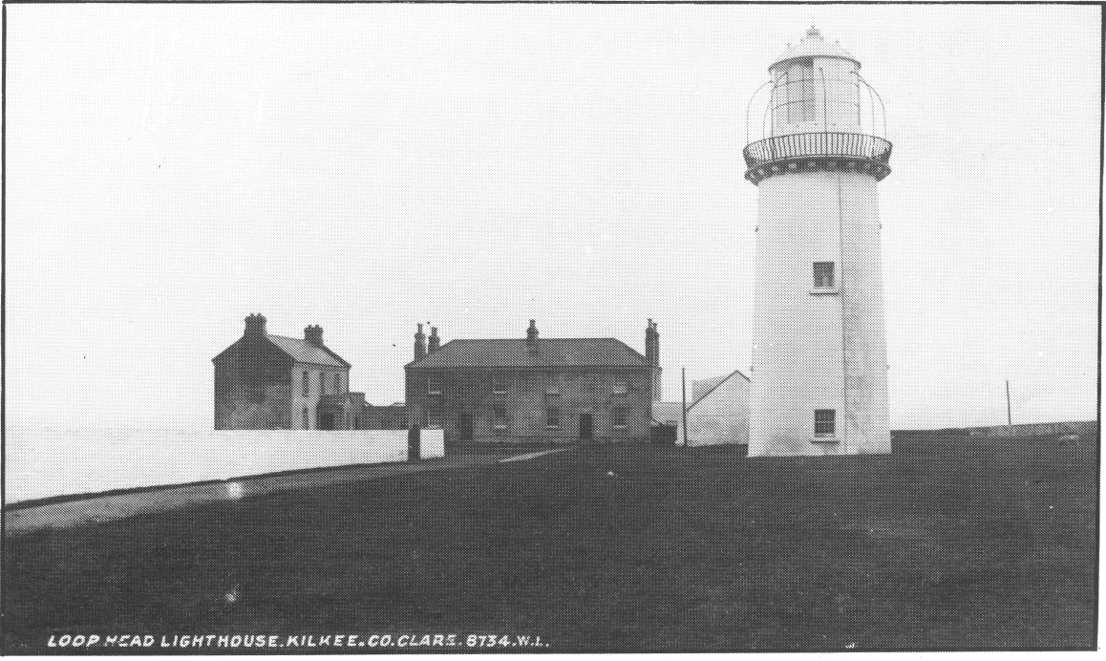
• Loop Head Light house at the turn of the century. The Lawrence Collection, Clare County Library.
119
but did you ever hear that fifteen ships of the Spanish Armada sailed in here between Reha Head and Carrigaholt Bay in search of water. Sure 'twas how one of them was wrecked off the point known as Spanish Point, and two boat-loads of them, they used to say - a hundred soldiers - were hanged, drawn and quartered on Mutton Island (off the coast of Quilty) by the English soldiers'. (IFC 1393 : 199).

Sea-Lore and Place-Names.

The place-names of the Clare coastline would provide ample material for an entire series of articles. Every rock and cave and inlet, every island and strand, had not only a name of its own but also, as often as not, some story attaching to it, in explanation of its name or otherwise.
For example, Seán Ó Flannagáin collected a story about a place called Aill na Searrach, or the Cliff of the Foals, near Moher. The story was told by Pádraig Mac-Cathaláin, of Castlequarter. According to Pádraig, a local farmer had a field of oats growing beside Aill na Searach. Much to the farmer's annoyance, he discovered that animals were breaking into his field every night, and eating his oats. He and his neighbours decide to keep watch over the field at night, and are astonished to see a herd of foals coming out of the sea at the cliffs and making for the oats. They chase the foals, in an attempt to catch them, as horses from the sea were traditionally said to be very good for breeding purposes. They succeeded in catching one, a stallion, and the rest escaped over the cliff at Aill na Searrach. It was subsequently said that the progeny of this sea-stallion were far superior to other local horses (IFC 537 : 506-8).
Other similar stories have been collected about this one small spot on the Clare coastline. Such a wealth of place-name lore indicates an extremely intimate relationship between the people and their environment, and a knowledge which comes only from having lived and worked in a place for a long time.
In the Kilbaha area, there is a tradition that a family called Costello used to live on Gull Island, surviving on birds and wild fowl. At that time, the island was connected to the mainland, but the power of the sea has since done away with this natural bridge (IFC 1392 : 172). Another tradition about Gull Island holds that it was once the home of a supernatural, although apparently benevolent, bull who used to serve the cows of poor people in the area, thus saving them money (IFC 1392 : 307).

Inis Cathaigh and St. Senan.

Scattery Island, or Inis Cathaigh, is probably the best-known of all the islands off the coast of Clare. The following explanation of the island's name was recorded by Seán MacCraith:
'Twas called Inis Cathaigh long ago, and that meant the island of the whale or monster that was named Cathrach (sic). St. Senan banished the monster, and as it left the island, it took a bite of the ground... on the road from Kilkee into Kilrush. They used to call that the Serpent's Bite, or Gleann na Péiste... (IFC 1414: 195).
St. Senan went on to establish a monastery on Scattery Island, and a great deal of tradition about St. Senan was recorded by the Irish Folklore Commission. This includes stories about his birth, the way in which he got his name, his boyhood deeds and his miraculous powers. The following was recorded from John Melican, of Scattery Island:
`The very first miracle St. Senan worked was to bring back to life seven young monks, who went out catching rock-fish. St. Senan told them not to go, but they
were young and foolish. But out they go, and a big wave coming upset their craft, and they were all drowned.
Senan collected their bodies and, placing them in the shape of a cross - that is, four lengthwise and three abreast - and brought them to life again. They were all angry at being brought to life, and each begged Senan to be restored again to the sight of God. This Senan did, and the seven bodies were buried on the island. They were the very first to be buried here'. (IFC 1358 : 348).
Inevitably, there are many places on the island which are associated with the saint. Prominent among these is St. Senan's Well, at which a pattern used to be held. The `rounds' at this pattern included the taking of a drink of water from the holy well, along with the usual rather complicated formula of prayers and other actions.
Obviously, there was a great deal of very genuine devotion to St. Senan on Scattery Island. Seán Mac-Craith writes the following:
`Whilst each and everyone of the island folks possess a wonderful sense of religious fervour... they place as much faith in the piece of stone they carry around their necks, or around their waists, as what a mainlander places in his scapulars... When they are leaving their island home for the first time, they are given a small stone, taken from St. Senan's grave... This stone is either pierced to allow a bit of string to go through, or else it is secured to a piece of string in such a fashion that any knot-maker would marvel at. The emblem is worn next the skin, and at no time is it ever removed'. (IFC 1358 : 335).
The passage quoted above is taken from a very detailed, and extremely interesting, account of the island which Seán MacCraith wrote in 1954. He describes the everyday life of the islanders, as well as their traditions and beliefs. The following are a number of extracts from his account:
`An island of exactly one hundred acres, it is owned by the families who today are living there. Each family had its own piece of ground, and thus the nine families may be classed as very small farmers. Each farm has an average area of six acres, and while the island folk are not entirely self-supporting, they manage to `get a lot' from their farms. It must be recorded that, even though the male inhabitants of Inis Cathaigh are listed in the Electoral Lists as farmers, each and every man has spent a life-time at sea in the Merchant Marine, or those who do not go to sea join the Irish Lights. Thus, every man today living on the island are pensioners from one or the other service.
Access to the island is by boat (currach) and, although it is only a mile from the mainland, islanders very often have to travel as much as four miles in order to reach their home, and then they will have cheated the ever-dangerous currents that sweep in the Shan-non Estuary. There is no road at all throughout the length and breadth of Inis Cathaigh. By-ways are simply narrow tracks, wide enough to allow an ass-and-car to travel. Not, of course, that there is any great use for even the ass-and-car - the only time such a vehicle is used is at the time of hay-saving.
A point of interest here: As stated, there are no roads on Inis Cathaigh, but the nearby main lane of shipping to the port of Limerick is charted as being `The Scattery Roads'. So when an islander wants to ridicule one of the folks on the mainland, he usually says: `That fellow wouldn't be able to tell on which side of the Scattery Roads he was walking!'.
`There are on Inis Cathaigh today nine houses, all inhabited. All the houses are of the same style - of stone, single-storeyd, with a good thatched roof and a white-washed four sides. On the majority of houses,
121
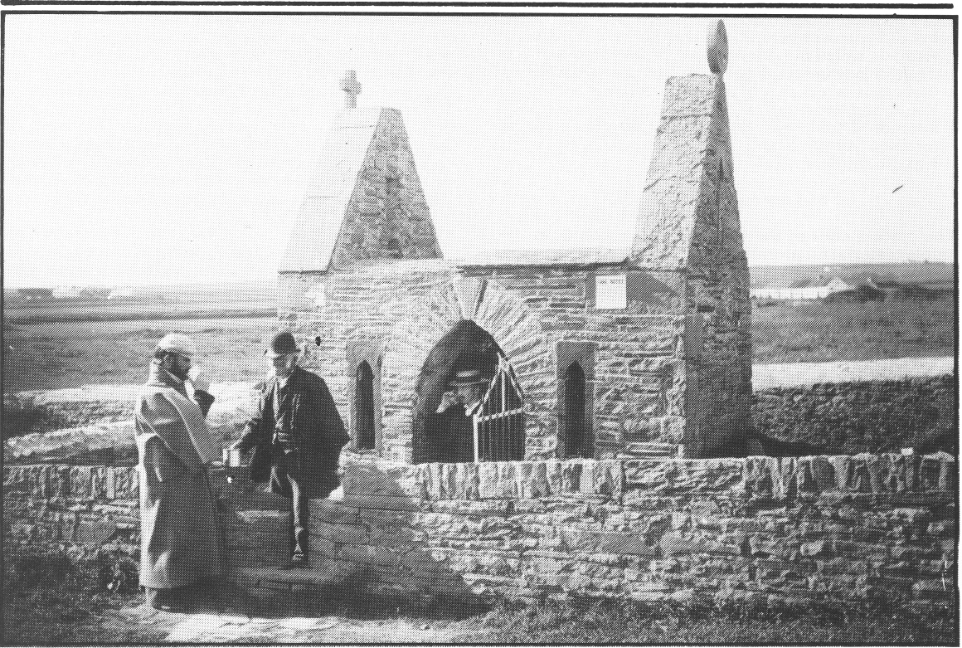
• Senan's Well. The Lawrence Collection, Clare County Library.
which are all built facing north-west (towards Kilrush), there are two chimneys. This additional structure helps if the wind is blowing from an unusual angle, and the second chimney has been built to offset a puff-down. So it's just a case of taking the hearth-fire to the other fireplace. The main living apartment is the kitchen, usually a very spacious room, so as to accommodate the entire island population on the day of the station Mass'. (8).
`There are usually two windows in the kitchen, each with a built-in seat, underneath which is incorporated the `seaman's chest', (which) the man of the house had when he was at sea. These chests usually contain... documents, such as post-office books, pension books wireless licences, documents concerned with the sea, a dictionary, prayer-books and, in each and every house, one is sure to find a copy of Old Moore's; Almanac'.
`One particular feature common to every kitchen on the island is the screened-in shelf that closets the wireless. The wireless was far more common to the island folk in its early years of inception than what it was to the folks in Kilrush, and the men on Scattery pay very great attention to the news broadcasts, but place very little faith in the weather forecasts.
On the mantle-shelf can be seen different types of `bottled ships' - usually miniatures of the old sailing ships.
One unusual feature of note in the kitchens of Scattery is the amount of books that adorn the top of the big press (which) there is in every kitchen. Islanders are very good talkers, very good listeners, but they are very fine readers. So the collection of books to be seen on the shelves, in some of these island homes, are worthwhile and, strange as it may seem, only very few of the books read by the islanders have any connection to the sea'.
In addition to the ordinary big-faced, eight-day clock, hanging at a corner of the fire-place, one can see, in all the island homes, a collection of ships' clocks, one or more in each house. This clock may have been taken from a ship that was broken up in one of Belfast's ship-yards, or that unusual clock may have come from a ship, still tramping the world but minus its clock, due to the sentimentality of some Scattery sailor.
In the kitchen of Austin McMahon, late extra master-mariner, is the 400-day clock from the three-master sailing ship Salterbeck, that was owned by a Captain James Murray of Kilrush, and who used to ship kelp and `square sets' (flag-stones) from Cappa pier, Kilrush, to St. John's, Newfoundland. The crew of the Salterbeck were, to a man, all Scattery men, and the ship's record is that of having made the round trip in the spring of 1903 in `eight weeks and five days'.
Nearly all the island houses possess a `Victrola' type of gramophone. These were nearly all imported from the U.S.A. and sailors returning to Ireland took advantage of the facility of taking back such with them. Up to about 20 years ago, prior to the broadcasting of variety programmes, the islanders were always swapping records with their neighbours, but the advent of the present-day radio programmes put an end to such practice'.
(IFC 1358 : 305-19, passim).
Today the island of Scattery is uninhabited.

"He told no lie":
Cill Stuithín and the Underwater World.

As well as the many natural islands along its coastline, Clare also had its share of supernatural and enchanted islands, and submerged cities. Stiofán Ó hEalaoire was a well-known story-teller who lived near Doolin, and from whom Séamus Ó Duilearga collected a great deal of
122
material, including lore about the sea (9). Stiofán told of a fine town which lies underneath the waters of Galway Bay, and which is occasionally seen to rise from the sea. The name of this land is Beag-Árainn (10).
There are accounts of an island which lies off the coast at Loop Head, and which may sometimes be seen on a summer's evening. There are two giant towers on this island, and they say it is covered with gold and silver, underneath its surface (IFC 1436 : 76). The following account is from the Carrigaholt area:
`They say it can be seen if you look though the mist, but then it's supposed to be seen at only every seven years. Some says it's seen on the 8th of March, which is St. Senan's feast-day, and others say it appears on the first full moon in the month of Samhna. It's supposed to be a hidden city of fairies, and they used to say that a fellow named Seán Buachaill (Brennan), who was born after his father died, once when he was out fishing, saw two giant towers like church steeples underneath the water. That fellow was supposed to be able to see a ghost, but he's dead for nearly sixty years. And though a lot didn't believe that tale, I would, as the water around there is a churn-pot, and maybe there is a hidden town or city there, and sure the good people may be living under there. This place is just south of the Loop Head, more to the Horse Island side of the place'. (IFC 1393 : 204).
The name of this island, according to tradition, is Oileán Dish (11) (sic) (IFC 1393 : 204).
The best-known of Clare's enchanted islands, however, is Cill Stuithín. Cill Stuithín lies off the west coast of Clare and the following account, involving St. Senan, explains how it became submerged in the first place:
`St. Senan was travelling from Ross to Kilcredaun - himself and his mother. He was to visit St. Crodán, and the night was very bad as he came to the village of Cill Stuithín - Cill Stuithín wasn't submerged at the time. He asked lodgings and he was refused it, and he cursed the village, and the village got submerged very soon after that'. (IFC 861 : 971-2).
Mrs. Brigid Costello of Kilbaha told Tadgh Ó Murchú about a personal experience of the husband of a woman she knew:
`Ach tá áit soir amach ó Charraig an Chabhaltaigh, go nglaoitear Cill Stuithín air. D'fheictí baile ansin sa seanaimsir go minic. Ach do bhí an fear seo ag caitheamh amach an ancaire as an long.... agus nuair a scaoil sé síos é, do labhair an fear thíos. `Cumaraí m'anama ort!' arsa é sin. `Tá tú ag scaoileadh anuas ar an bhfar-doras! `Bhfuil fonn ort le haghaidhe é leagadh? Tarraing!'
Tharraing sé an t-ancaire is scaoileadh an long amach níos sia insan bhfarraige, is scaoileadh suas (sic) an tancaire ansin. Ach tá fhios agam de réir mar atá aithint agam ar an ndream... a tháinig ina dhiaidh, go mba fear macánta é - nár inis sé aon bhréag.
Ach an fear céanna, dúradh gur báthadh ina dhiaidh sin é'. (IFC 861 : 757-8).
(But there is a place out from Carrigaholt that they call Cill Stuithín. There used to be a town seen there often in the old days. But this man was throwing the anchor out from the ship... and when he let it down, a man below spoke. `Help me' he said. `You are letting your anchor down on the lintel of the door. Do you want to knock it? Pull it up!'
He pulled up the anchor and let the ship out further into the sea, and let down (?) the anchor there. But I know from the people who came after him that he was an honest man; that he told no lie.
But that same man, 'twas said he was drowned after that).
The drowning of the man in this last story may well be connected to the belief that anyone who sees Cill
Stuithín will be dead within twelve months (IFC 1042 : 134) .
Tadhg Ó Murchú also recorded several accounts of sightings of Cill Stuithín from Seán Ó Maoldhomhnaigh of Rahona. These include a first-hand experience which Seán himself and his sister had, when they saw an enormous number of lights early one morning at the mouth of the Shannon. They believed that what they had seen was Cill Stuithín (IFC 861 : 818-20).
Another of Seán's stories tells of a local man, whom Seán knew, who claimed to have visited Cill Stuithín. He was brought there by a strange man whom he met on the beach one day. He described Cill Stuithín as being a fine place, where there was sport and dancing and music and games, and every kind of refreshment. He described the fine candle-holders which were there and which he refrained from touching, although he wanted to. As he leaves Cill Stuithín to return home, an old woman at the door derides him for not touching the candle-holders, and tells him that it is the like of him that has Ireland destroyed. The man understands from this that, had he touched the candle-holders, Cill Stuithín would have been disenchanted, and would have remained visible for ever (IFC 861 : 820-2). Similar motifs are found in the tradition of other parts of the country as, of course, are most of the motifs which are met with in the sea-lore of Clare.
As with other enchanted islands, it was said that Cill Stuithín could be disenchanted by throwing a handful of clay onto it. A Kilcredaun man who attempted this was distracted by a little dog who tried to bite his heel. When the man turned his attention to Cill Stuithín again, he found that it had disappeared completely (IFC 861 : 822) .
According to Stiofán Ó hEalaoire, Cill Stuithín can be disenchanted only by getting hold of a key which is in a lake at the top of Sliabh Chollán As if this weren't difficult enough, Stiofán adds that this lake is seen only once every seven years (12).
On an optimistic note, it is worth mentioning that a local Kilbaha prophet, Máirtín Donncha McMahon, has said that the Shannon and the Atlantic will one day unite and try to drown the whole of the west. This will happen on a famous feast-day, apparently. This prophecy was naturally referred to when a big tidal wave hit Carrigaholt at Christmas-time in 1952. (IFC 1393 : 221).

Obviously, these underwater islands and cities had to be populated by somebody. In this connection, the following story was recorded by Tadgh Ó Murchú in Rahona:
`Bhí aithint agam ar sheanfhear... Rugadh agus tógadh ar an gCill Chróin é, agus an t-am sin bhí ana-chuid curacha ag dul ag iascach scadán ó Charraig an Chabhaltaigh. Bhíodh se ag iascaireacht gach aon oíche sa bhfómhar... An oíche seo, nuair a thógadar na heangacha, bhí leanbh insna heangacha, agus bhí sé ag béiceadh. Thógadar isteach an leanbh agus thángadar i dtír - cheapadar an leanbh a thabhairt go dtí an sagart.
Ansin, cheapadar b'fhéidir ná raibh sé ceart é a dhéanamh, agus chuireadar an leanbh isteach sa churach agus d'imíodar amach go dtí timpeall an áit chéanna a fuaireadar an leanbh, agus nuair a bhí siad ag gabháil amach, cheapadar gur airíodar an bhean ag gol san
uisce. Ligeadar síos an leanbh insan áit ar furadh é, no gairid dó, agus gach aon oíche as sin amach, pé ar domhan áit a chaithidíst na heangacha, bheadh an curach tan de scadán acu.
Bhí an fear á n-insint (sic) dom é féin, agus fear macánta ba ea é... Bhí mo dheirfiúrsa pósta go mhac an fhir sin. Bhí an fear a bhí á n-insint dom suas le ceithre fichid bliain an t-am sin, agus fear é ná n-inseodh aon éitheach.
123
Dúirt sé go mba chosúil le haon leanbh saolta é, ach go raibh craiceann an éisc air'. (IFC 861 : 824-5).
(I knew an old man... He was born and reared in Cill Chróin, and that time there were a lot of currachs going fishing herring from Carrigaholt. He used be fishing every night in autumn... This night, when they took in the nets, there was a child in the nets and he roaring. They brought the child into the boat, and came into land - they intended to take the child to the priest.
Then they thought better of it, and they put the child into the currach and went out to about the same place where they got the child. And when they were going out, they thought they heard a woman crying in the water. They let down the child in the place they found him or near to it, and every night from that on, wherever they cast their nets, the currach would be full of herring.
The man was telling me himself, and he was an honest man... My sister was married to that man's son. The man who was telling me was up to 80 years old that time, and he was not a man to tell lies.
He said he was like any human child, but he had the skin_of a fish).
Another story from Rahona tells of some pilots who were going back to Brandon one day in a currach. When they were five or six miles south-west of Loop Head, a man suddenly stuck his head up out of the sea. He said nothing, but put his hand on the end of the currach, and looked at the pilots. The pilots turned at once and made for Loop Head. They eventually came ashore at Horse Island, and had their currach just settled when a terrible storm arose, in which they would surely have been lost. (IFC 930: 439-40).

"He was supposed to have seen this Madra Liath":
Omens of drowning.

There are many similar stories, in Clare and elsewhere, of supernatural beings warning men at sea of approaching bad weather. A supernatural appearance of any type was generally taken as an omen of misfortune of one kind or another.
It is interesting to note that, in the case of stories about supernatural sea-beings, tradition usually does not specify exactly what type of being is involved. This lack of definition is a feature of Irish sea-lore generally. Most of the time, there is a great ambiguity attached to the under-water population, and a great deal of overlap between the worlds of sea-fairies, mermaids, the spirits of those drowned at sea, seal-people etc.
The following story illustrates the belief that fisher-men should be especially careful when going fishing in the early morning, as the inhabitants of the otherworld, instead of their earthly fishing-partners, may call them to waken them. This belief is to be found in other coastal areas as well as in Clare. The story tells of a fisherman who is called to go fishing in the small hours of the morning, as agreed with his comrades the night before. He gets up and, seeing that there is no light in the houses of his two companions, presumes that they are gone on ahead to the place where their boat is moored. The storyteller, from Corbally, continues:
`Off he sets... and he heads for the Flags below near the bay. He walked and walked, and from where he walked he could see the 22 canoes resting below, but devil the sign of his two men.
When he had crossed the clogher (13) at Baltard, he knew he had only two or three fields to cross now, so he put a spurt into his walking. Coming off the cliff after coming through the few fields, and he saw two men walking away from the Flags with a canoe on their heads.
(You know how two men pick up a canoe and walk away with it resting on their shoulders). He reached the Flags himself, and when he looked for his canoe, it wasn't there. Neither were the six oars, nor the two fish scuttles nor spillers. He was then certain that the two men he had seen were indeed his two partners. And so he quickened his pace and headed for the water's edge.
He saw the two men in the distance, and then he saw a third, and he was taken a bit back (frightened). As he drew almost level with the three men, he was about to talk to them, when two of them pushed the canoe into the water, and they jumped in. Then the third man jumped into her stern, and out to sea they went.
The hair stood up on Pat's head and, as quick as he could, he raced back the way he came, looking at the empty place where his own canoe and trappings should be. But it was still empty. The grass didn't grow under his feet as he raced back to the first house (his partner's) and he nearly put the door in with his knocking. Up gets his partner out of bed and Pat asks him if the third partner had called him. `No', said the partner, so up Pat gets and tells his story to his partner. The two of them go off to the third partner, who had to be got out of bed also, and when he had heard Pat's strange tale, he decided that the three of them had best go to the Flags, and see for themselves.
Back they go, the three of them, and when they reached the Flags, there - in what Pat said was an empty place - stood their own canoe, with its six oars, two scuttles and three nets. The two partners looked at poor Pat and laughed at him, but he swore that what he was after telling them was the truth. But no amount of telling would convince them and, to the day he died, no-one ever believed him. And on the night that he did die, those two partners were out fishing with another man and, coming inshore, they were passed by a strange canoe with three silent men in it. Only the two old partners saw it - the third man didn't see a thing.
When they landed, they heard that poor old Pat was after dying in his bed - he'd been ailing for a time. Then, and only then, did they believe that what old Pat had told them was what he had indeed seen with his own two eyes'. (IFC 1393 : 320-3).
This story is a good illustration of the constant overlap between the world of the dead, and that of fairies, etc., as mentioned above.
Another fairly typical traditional story is that told by Stiofán Ó hEalaoire about a woman who is visited by her drowned husband. He tells her how she can rescue him from the host of the dead by using a mixture of hen-dirt, urine and a certain herb. Because of her indiscretion, however, the herb cannot be found when it is needed and her husband is not rescued (14). This story is quite commonly met with throughout the country, in land-contexts as well as sea-contexts. This particular version again underlines the overlap between the world of the sea-fairies, and that of those drowned at sea. The belief which is central to this version, - i.e. that a drowned per-son does not die naturally, but is actually taken by the fairies - is to be found in other parts of Clare, and elsewhere throughout the country.
One north Clare belief which is not common elsewhere is that a drowned person would be sure to go to heaven. This was recorded by Sean MacMathúna, and went as follows:
Ach d'airíomar go léir go mba mhaith an scéal don té a d'fhaigheadh bás le bá, mar nár bhaol d’’anam an duine sin'. (IFC 553 : 380-1).
('But we all heard that it was a good thing for a person to drown, because that person's soul would be in no danger').
125
Generally, however, the belief that drowned people were taken by the sea-fairies is much more widespread. This belief naturally led to a certain fear of the fairies or, at least, a healthy respect for them. In the same connection, it was believed that sea-fairies - like their terrestrial counterparts - could control and change the weather thus, in turn, bringing about the drowning of chosen individuals. For this reason, sea-fairies often appear in tradition as being positively malevolent.
Still on the subject of drowning, accounts have been recorded from Clare which indicate the existence of the belief that it was unlucky, or inadvisable, to help those in trouble at sea This belief is found all around the coasts of Ireland, and abroad. Understandably, this often led to bad feeling between families of the fishermen involved. The belief is probably based, in part, on a familiarity with the practicalities of a dangerous situation at sea. In many such situations, the would-be rescuer would probably not be able to help the party in trouble, and would simply run a very real risk of getting into difficulties himself. People were sensible enough to realise the futility of being a dead hero. At the same time, the reluctance to help those in trouble probably also had something to do with the belief that, should you rescue someone at sea, the drowning will fall on yourself the next time around. Looked at objectively, this view of things is quite a natural result of the belief that drowned people are, in fact, abducted by sea-fairies. Needless to say, the practice of not trying to help a drowning person has long been obsolete in Co. Clare, and throughout the rest of the country.
Understandably, and in similar vein, there was some-times a certain reluctance among fishermen to tamper with the bodies of those who had drowned. For example, it was regarded as an omen of bad luck to catch a body in the nets while at sea (IFC 1391 : 99-100). The belief is also found in many other parts of the country.
Another omen of drowning is described in the following piece, recorded in the Kilbaha area:
`They used to say that this grey dog, or the madra liath, used to always follow canoes that were doomed to be drowned. Once it's supposed to have followed (a particular family), and Henry's father saw it, but he would not go out again in that canoe. Instead, he went fishing with two other men. A short time after he changing, wasn't the canoe lost, and the three men on it were drowned. And two of them were with Henry's father the night he was supposed to have seen this madra liath'. (IFC 1393 : 208).
This particular omen of death is not, to my knowledge, to be found in other parts of the country. In common with other areas, however, Clare people hold the belief that a baby's caul is a sure protection against drowning (IFC 1391 : 80).
There are many stories from all parts of Clare about people who had encounters with boats or ships from the otherworld. Some of these encounters have already been described. Others include the account of the man who was walking from Fanore to Ballyvaughan one morning before daylight. Below him in the sea, he could hear the noise of oars hitting the water, and of men talking, and he could just make out the shape of a currach. He was later to discover that there was, in fact, no currach out at sea at the time (IFC 695: 115-7).
In the Kilbaha area, a long-boat full of 20 monks is said to be seen sometimes. This belief is possibly related to the tradition that over 100 monks and priests were thrown into the sea off Hog Island at the time of the suppression of the monasteries. They are said to have been taken from the monastery on Scattery Island (IFC 1393 : 207).
It was not at all uncommon for people who witnessed such phenomena to die within a fairly short length of
time. The belief that they should do so is a very natural reaction to supernatural intervention, and is quite wide-spread in its distribution.
"She used to be singing when they saw her":
The Lore of the Mermaid.

As well as the spirits of the drowned, the sea-fairies and the phantom boats, there were other supernatural beings at sea. These included the mermaid - a figure who has been romanticised and bowdlerised almost out of recognition over the last couple of centuries. As with the submerged lands and islands off our coast, many people do not realise that there existed a strong and widespread belief in the mermaid, until comparatively recently. Thomas Johnson Westropp, the Limerick antiquarian who did such pioneering collecting work in the west of Ireland, makes the same point about the mermaid in his work on Clare folklore. Writing in 1910, he had this to say:
‘There was some belief in mer-folk at Kilkee before 1879, but it has nowadays got touched up for tourists'. (15).
The following account is from the Doolin area:
Ní fheiceann éinne anois í, ach deireadh cuid den seandream go bhfacadar féin í. Tá carraig cois na farraige insna haillte seo thíos, a dtugtar Licín (nó Leac) na Mná Uaisle air, agus dá mb'fhíor do sheandaoine é, is ansin cois na toinne do thugadh sí í féin le feiscint. Nil an-fhada in aon chor ó cailleadh fear comharasan dom a deireadh go bhfaca sé an bhrúch timpeall na háite sin. Dúirt go leor eile nach é, go bhfacadar féin í.
De réir gach tuairisc (sic), is bean atá insan leath uachtarach den bhrúch, agus iasc insan leath`íochtarach. Agus is ag cíoradh a gruaigh álainn (sic) le cíor óir bhíodh sí gach uair do chonachtas riamh í, dá mb'fhíor an dream do chonaic í.
Níorbh fhurasta teacht uirthi, mar dá thuisce agus
d'fheiceach sí an peacach, isteach lei faoin dtonn do
bhíodh i gcónaí gairid di. Cuid a deireadh go mbíodh sí
ag amhrán nuair do chonaiceadar í'. (IFC 1043 : 7-8). (`No-one sees her now, but some of the old people said they saw her themselves. There's a rock beside the sea at the cliffs here below that they call the Rock of the Noble Woman, and if it's true for the old people, it's there beside the tide she used allow herself to be seen. It's not so long at all since a neighbouring man died who used to say he saw the mermaid around that place. A lot more besides said that they saw her themselves.
According to the reports, the top half of the mermaid is a woman, and the lower half is a fish. And she used to be combing her beautiful hair with a golden comb every time she was ever seen, if it's true for the crowd who saw her. It wasn't easy to come on her, because as soon as she'd see someone, down with her under the waves which she was always near. Some said she used to be singing when they saw her!)
There are a number of versions of a story about a mermaid who succeeded in swimming up-river to a castle, where she was found drinking wine in the wine-cellars! There is some differences among the versions about the locations of the castle and about what happened to the mermaid then, but one version from Doolin claims that the incident took place in the old castle at Lahinch and that the mermaid was released back into the sea, after being beaten for her impudence (IFC 1043 : 3-9).
In several of the accounts of people who saw the mermaid, there is a definite reluctance on the part of the people in question to have anything to do with her. Again, people evidently regarded her as an omen of ill-fortune and generally preferred not to see her. In the case of one such account from the Liscannor area a
126
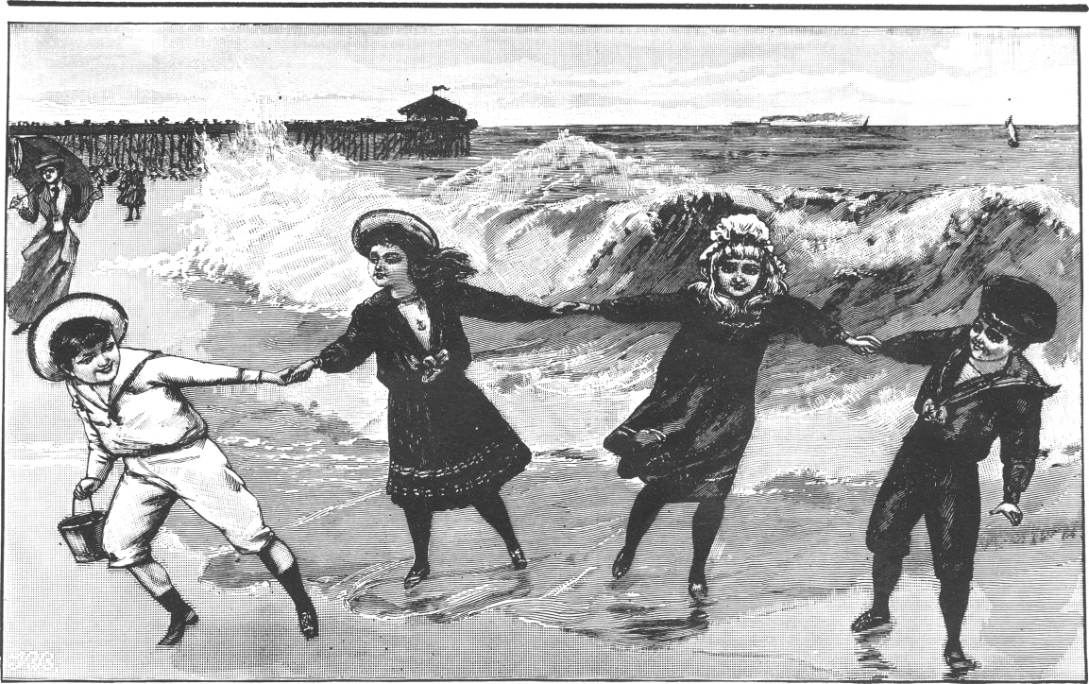
fisherman who repeatedly saw the mermaid was advised by his priest to go to America, apparently in an attempt to get away as far as possible from her. He did this, and stayed in America for seven years before returning home. He never saw the mermaid again after that (IFC 1043 : 9-10).
Seán McMathúna collected a version of the story of the three laughs of the mermaid from Aguistín Ó Diolain, the well-known story-teller from near Liscannor. Aguistín's story concerned a man who caught a mermaid one day, and brought her home to his house. As they entered the door of the house, the man banged his foot off the doorstep, at which the mermaid laughed. Later on, a visitor calls to the house and refuses the offer of something to eat. At this, the mermaid laughs again. As the visitor goes out, he also bangs his foot on the doorstep, and the mermaid laughs a third time.
When her captor asks her why she laughed, she agrees to tell him, as long as he promises to leave her back to the sea. He promises her this, and she tells him that there is a pot of gold hidden under the doorstep, and that the visitor left his happiness after him when he refused the offer of something to eat. Her captor then leaves the mermaid back to the sea, where he finds another mermaid waiting for her. The other mermaid asks her `Did you tell him the good of a black hen's egg?', to which the first mermaid replies `The curse of the woman who combed her hair on Friday if I did!' (IFC 1044: 143-4).
A story with similar motifs is told about the leprechaun in Irish tradition, and the same motifs occur in legends in other countries throughout Europe and beyond.
The story of the man who married the mermaid is another international tale which is found in Clare sea-lore and, indeed, in many other parts of Ireland. Over 300 versions of the story have been recorded in this country, and it also occurs all over the north Atlantic area - in Scotland, Iceland, the Faroe Islands, Denmark and Norway. Tadhg Ó Murchú recorded a good version of the story from Pádraig Ó Briain in Corbally. The gist
of it is as follows:
A local man is fishing from the cliffs one day when he happens to see a mermaid. He approaches her, and starts a conversation with her. As they are talking, he sees her cloak behind her. He knows that she cannot return to the sea without her cloak, so he grabs it, and makes off with it. The mermaid, of course, has no choice but to follow him, and this she does. They go back to the fisherman's house, and he hides the cloak in the loft. She stays in the house with him, and marries him, and they have a son and a daughter. One day, however, the fisherman is out at sea fishing when his wife comes across her cloak on the loft. As soon as she finds it, she heads straight back to the sea. Her husband comes home to find her gone, and never sees her again (IFC 961 : 47-50) .
Westropp had the following to say about mermaid traditions in Clare:
`The last reported appearance of a mermaid is so recent as the end of April, 1910. Several people, including Martin Griffin, my informant, saw what they are firmly convinced was a mer-woman in a cove a little to the north of Spanish Point, near Miltown Malbay. She was white-skinned and had well-shaped white hands. The party tried to make friends with her, giving her bread, which she ate. Then a Quilty fisher-man got frightened, said she was `something bad', and threw a pebble at her, on which she plunged into the sea and disappeared. Soon afterwards King Edward died. An old man at Spanish Point said the last mermaid was seen the year of the Great Famine (1846), and that such an appearance foretells a public disaster' (16).
Stiofán Ó hEalaoire had a story about a man who caught a mermaid, brought her home, and had her in his house for a while. One day, he catches a seal, and proceeds to bring that into the house as well. As soon as the mermaid sees the seal, she cries `Vó, Vó! Nach deas an obair í seo! `Síod é mo dhriotháir gofa anois acu!' (Vó,
127
Vó! Isn't this nice work! Now they have caught my brother!'). The two of them then run off back into the sea again (17).

"There was a funeral of Seals":
An Animal world under the waves.

This story provides further illustration of the overlap between the realms of the different creatures of the sea. It also leads us nicely onto the subject of seals, about whom there is a rich vein of tradition, in Clare as elsewhere. Seals are very interesting animals, and their behaviour often seems to closely resemble that of human beings. It is not surprising that they should figure prominently in the lore of the sea. The following story is from the Kilbaha area:
'Áit mhór rónta is ea an áit seo, agus do bhí fear anseo fadó go dtugtaí Bártach O mBaoill air, a bhíodh ag marú na rónta, agus bata mór aige - stráice mór de mhaide aige. Well, tháinig sé oíche - oíche ghealaí - go dtí gág a bhí ann, agus bhí an rón istigh sa ngág, agus nuair a bhí sé ag tarraingt an mhaide uirthi `Ná buail me, a Bhártach Uí Bhaoill' a dúirt sí, `go gcuirfidh me an ceann óg díom!'.
`Dar lia' a dúirt sé `ní bhuailfead ná le mo shaol arís!' Bhí sé sin amhlaidh. Well, nuair a cailleadh ansin é... lá na sochraide, bhíofar á chur - ag dul go dtí an reilig leis - agus bhí... socraid rónta ag gabháil soir lasmuigh dhe... go ndeachadar chomh fada leis na reilig, ar an bhfarraige'. (IFC 860 : 489-90).
(This is a great place for seals, and there was a man here long ago that they used to call Bartach Ó mBaoill, and he used to be killing seals, and he had a big stick - a big stump of a stick.
Well, he came one night - a moonlit night - to a crevice that was there, and the seal was in the crevice. And when he was raising the stick over her, she said `Don't hit me, Bártach 0 mBaoill, until I give birth to my young'. `By dad' he said `I won't hit you now or ever again'. And that was so. Well, when he died then... the day of the funeral, they were burying him - going to the graveyard with him - and there was... a funeral of seals stretching back outside... until they got as far as the graveyard, on the sea').
This story illustrates the widely-held belief that seals have the power of speech. This, in turn, is connected to the belief that seals are in reality enchanted people, and that they can sometimes revert to human form. There are stories of seal people like mermaids - inter-marrying with humans, and specific families are said to have resulted from such a match, and to be related to the seals. In Galway, this is most often said about the Conneellys. Stiofán Ó hEalaoire tells a story about a seal who gets caught in fishing-nets at sea, and who speaks to the fishermen. This story seems to contain a reference to the belief that the Conneellys are related to the seals, (18) and Westropp also describes the existence of this tradition in Co. Clare (19).
All of this led to an understandable reluctance to harm seals or to kill them. For the most part, people tended to treat them with a certain wary respect. A typical, didactic-type tale from Corbally tells how a big, black seal used to always follow a particular canoe. One day, one of the crew tried to strike him with an oar...
.. and sure 'twas the worst thing that man ever did. That night, when he was going home after fishing, didn't he slip on the road and burst five ribs, and he never got out of his sick bed for twelve years until the day he died'. (IFC 1393 : 319).
On top of all of this, there was also believed to be a varied and active supernatural animal world under the waves. Reference has already been made to this in the stories connected with Aill na Searrach, near Moher, as
described earlier. And Aill na Searrach is not alone in Clare in being frequented by supernatural horses from the sea - the same tradition exists about a place near Kilclogher, in south Clare (IFC 860: 309-11), and about the caves of Kilcorney, near Ballyvaughan, in north Clare (IFC 537 : 264-5).
Seán MacMathúna collected a story from Cáit ní Fhlannagáin, who lived near Doolin, about a man who was gathering seaweed on the strand one day, when a calf came drifting in on the tide. The man brought the calf home, and built a high fence in order to stop him escaping. After one year, a lowing sound is heard from the sea one day, and the calf immediately jumps the fence. A cow is seen stretching her head up from the sea. The calf jumps into the water to join the cow, and is never seen again (IFC 708 : 521-3).

There are many other stories in Clare tradition about supernatural sea-animals, and about strange fish or monsters which were seen by fishermen at sea. Similarly, there are entire genres of tradition which I have hardly mentioned at all. These include the many songs from the coast of Clare, which form an important part of the sea-lore of the county.
All of this bears witness to the enormous wealth of tradition about the sea in Co. Clare. To attempt to document this richness in the space of one article is a bit like trying to walk on the Scattery Roads.
NOTES

- IFC = Irish Folklore Collection manuscripts, Department of Irish Folklore, University College Dublin. Throughout this article, Irish texts from the manuscripts have been partly standardised. The translations are my own.
- J. Hornell, British Coracles and Irish Curraghs (London 1938), pp. 24-8.
- Recorded by myself, for the Department of Irish Folklore, in August 1979 (Tape 19).
- Idem.
- The text of the song is on the following two pages of the manuscript.
- Untranscribed material recorded by Ciarán Bairéad, IFC T80a.
- J. Frost, The County of Clare (Dublin 1893), 96
- Station-Masses are held in several parts of the west of Ireland. They are held twice a year, in spring and autumn, and involve the saying of Mass in private houses, on a rotating basis.
- Much of this information has been published in Leabhar Stiofáin Uí Ealaoire, edited and prepared for publication by Séamus Ó Duilearga and Dáthí Ó hÓgáin (Baile Atha Cliath 1981).
- Ibid., 273.
- Cf. dís, meaning `two; pair, couple' (Ó Dónaill, Foclóir Gaeilge-Béarla, Baile Atha Cliath 1977).
- Béaloideas, 3 (1932), 274.
- Cf. clochar, meaning `stony place; stony ridge' (Ó Dónaill, op. cit).
- Ó Duilearga and Ó hÓgáin, op. cit., 248-9.
- `A Folklore Survey of County Clare', Folk-lore, 21 (1910), 342.
- Ibid, 342-3.
- 0 Duilearga and Ó hÓgáin, op. cit., 266.
- Ibid., 268.
- Westropp, op. cit., 483.
Acknowledgement

My thanks to Camille Murphy and Ríonach Ui Ógáin for their help with this article.
128

